**ŠTART**

**Slnečná sústava**

**Blue-Bot-Matte**

**Slnko**

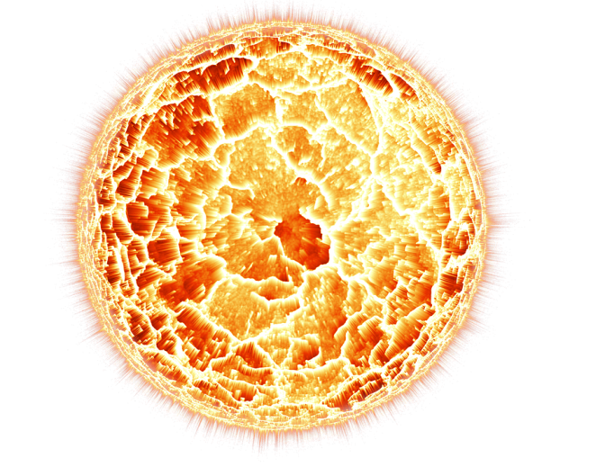

**Merkúr**

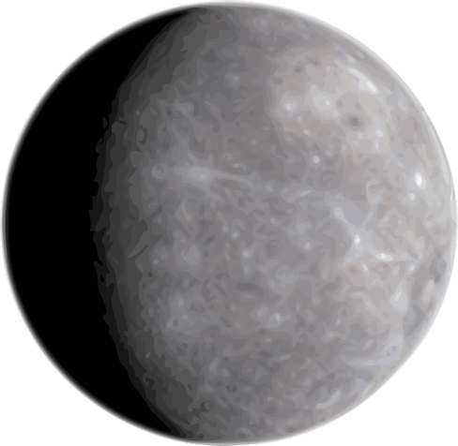

**Venuša**

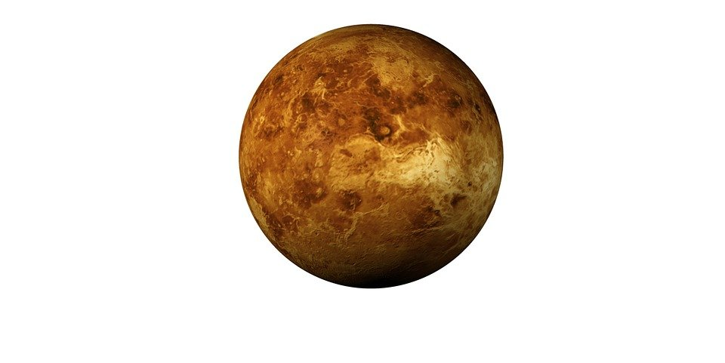

**Zem**

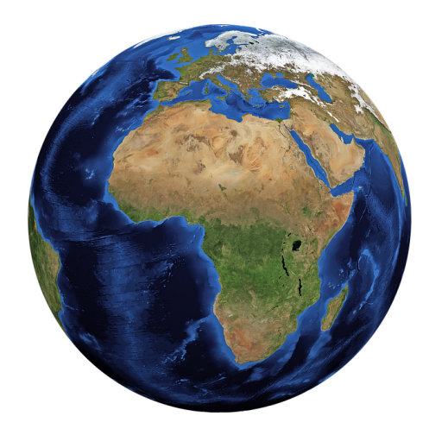

**Mesiac**

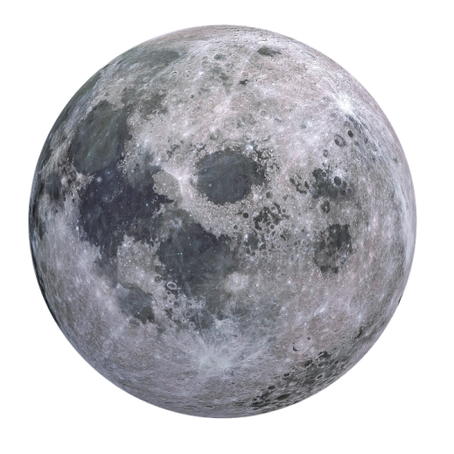

**Mars**

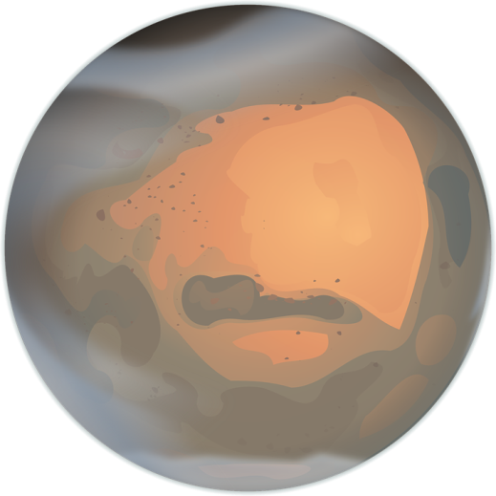

**Jupiter**

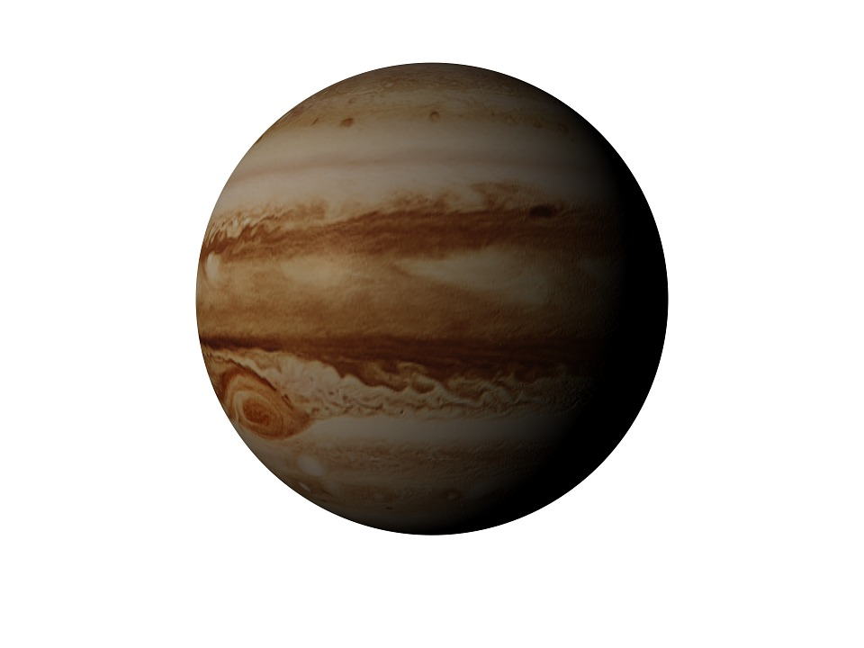

**Saturn**

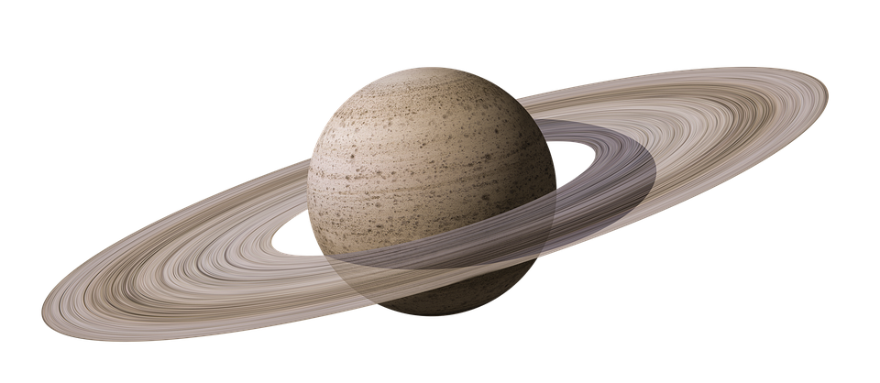

**Urán**

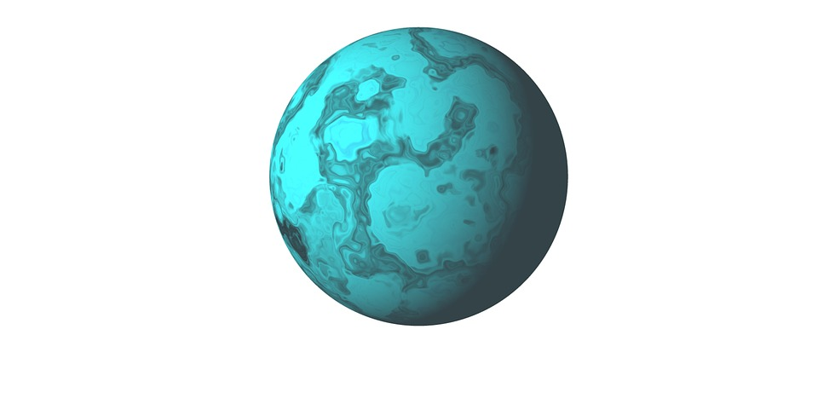

**Neptún**

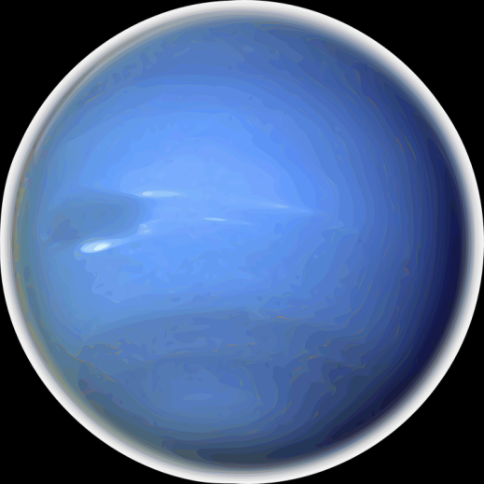

**Obrázky:**

Slnečná sústava <https://pixabay.com/photos/solar-system-sun-mercury-venus-439046/>

Slnko <https://pixabay.com/illustrations/planet-sun-star-1497205/>

Merkúr <https://pixabay.com/vectors/mercury-solar-system-planet-153570/>

Venuša <https://pixabay.com/illustrations/mars-venus-planet-titan-346939/>

Zem <https://pixabay.com/illustrations/earth-world-planet-globe-1303628/>

Mesiac <https://pixabay.com/illustrations/moon-planet-space-astronomy-1303512/>

Mars <https://pixabay.com/vectors/mars-martian-orange-planet-151143/>

Jupiter <https://pixabay.com/illustrations/jupiter-planet-space-astronomy-942558/>

Saturn <https://pixabay.com/illustrations/saturn-saturn-s-rings-planet-4314403/>

Urán <https://pixabay.com/illustrations/uranus-planet-neptune-346951/>

Neptún <https://pixabay.com/vectors/neptune-solar-system-planet-153571/>